Problem set

{it is to be made clear that this is just the problems and solutions to the set of problems that will be in the game. }

Problem set 1

The electricity has gone out in a building. Three generators must be powered up in a certain fashion to restore power. After each generator is turned on, a power switch must be flicked to divert power.

in a room there are a tile arranged in order 6x6 as shown below

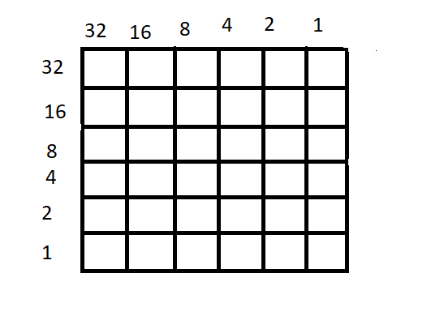

the room is divided into the tiles shown above. the tiles will light up a certain color. And according to the tile set that has lit up the player must find which room out of 20 the backup generator exists. After the generator is turned on. the player must go to the switch which will take a four-digit input to recognize which generator to divert power from.

Sample tile lighting

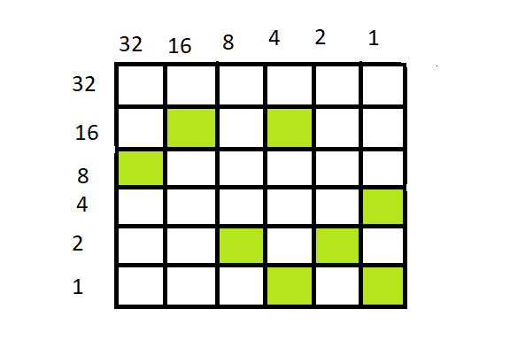



Solution:

The tile set readings are first taken horizontally

Adding the tile value in the columns(horizontal)

1st (0) + 2nd(16+4) + 3rd(32) + 4th(1) + 5th(8+2) + 6th(4+1)=68

Adding the values in the rows(vertical)

1st (8) + 2nd(16) + 3rd(2) + 4th(1+16) + 5th(2) + 6th(1+4)=50

Now you have two numbers with you 65 and 50

There are 20 rooms with a generator each. The generator is in room 18 as 68-50 is 18.

The code which identifies the 15th generator is 6850. Hence the problem to power up all three generators will be solved.

Constraints of the problem.

Let the sum of all the columns of the tile set is a

Let the sum of all the rows of the tile set be b

a-b<20

a ,b<100

Problem set 1.2

If the problem is too hard it will be simplified. The problem is modified to combat the time it might take for some of more beginner level players. As the same, the player will be taken into a 6x6 room, with randomly lit up areas. The horizontal and vertical areas will have different values as usual. Instead of having the player to add up the numbers without prompt, each end will have a monitor where they are expected to enter the number. After the number has been entered, they will be asked to enter the numbers in the rest off the monitors. After all the monitors on one side have had their respective numbers entered, a cord will emerge from the monitor. The player is to connect these into the monolith (hexagonal shaped object). After all the cords have been connected. The hexagon will show a value which is equal to the sum of all the numbers from the monitor. Once the two hexagons have been connected to the monitors and the numbers displayed, the rest of the problem functions as the above. the numbers on subtracting will give the room number which the generator is present, and the code to divert power to the generator will be a combination of the two numbers.

=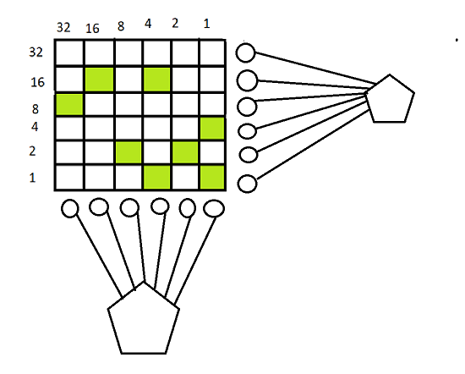

Problem set 2

The player is lead to a room of hexagonal shape. Each side has doors with letters A,B,C,D,E,F on each one of them as shown. The player is told to start with A. behind each door is a number. On each side there are 5 extension ports each with numbers in the power of two starting from 2^0 to 2^9. There is a monolith in the middle. The player should connect the appropriate ports to the monolith to get the sum. The solution is made into an equation(represented in binary with the connected ports as 1 and the unconnected as 0. As soon as the right answer is reached, the player is taken to the first floor of the room. The representation will be provided in the corner. The player is then given 2 containers and told to select four in the order at which the number is shown and placed in the container. The user is asked what number now is present in the container and upon identifying ten the player is said to have obtained A.

(This process repeats in each room until the player has obtained all the letters. Each room will have a unique problem and after all the letters have been obtained. The player is taken to the main room and the floor started moving upward. To a main even where the letters obtained are used to solve puzzles)

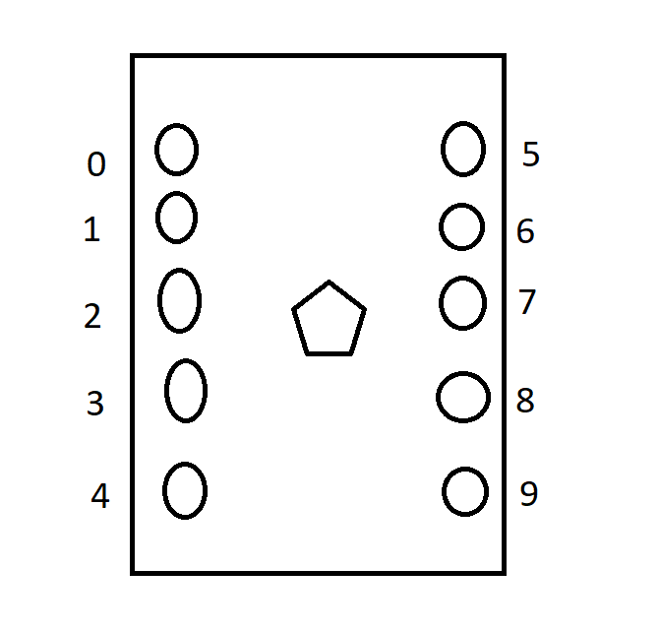

B

Once the player enters the room the number flashes on of the walls of the room. the player is told that a bunch of Lazer coming at them. The Lazers are arranged in a way which mimics the binary of the number shown. The Lazers which represent 1, are to be jumped over, the Lazers which represent 0 are harmless. Each time the player gets caught by a live Lazer, the walls close in. if the player manages to get completely crushed, they are teleported back to the hexagonal room and made to play all over again. The players are then told to collect all the numbers they jumped over and to.

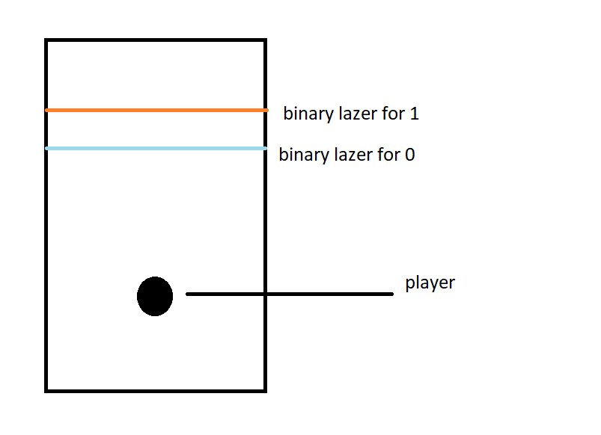

C

As a funny gag, when the player enters the room. the center contains only one box. On opening the box, the player is immediately given ‘C’. a text box appears and explains the significance of ‘C’.

D

The player then reaches the fourth room. but the room doesn’t not open. The player then must find the key that opens the door to the door so that the player can advance into the door. The player is prompted to open the open the keypad near the door. The player is presented with a set of wires. The wires are connected to the other end of the keypad. But the catch is that not all wires should be connected. There is a certain combination of wires that should be connected in a certain way. Which would unlock the door to access D

Once the door is accessed the player can enter the room. the room is dark. The player must find out what to do on their own.

**The puzzle in the dark**

The player is lead into a room. It Is a normal office with the lights off the only light is coming from a flashlight, that will be provided to the player

E

F

A chest lies in the center of the room. then when the player interacts with the chest. A large robot emerges from the chest and then engages in a pokemon turn by turn style of battle. When the robot’s time reaches, the